Willy Husted

CSI: OS

Windows:

Pre-OS software

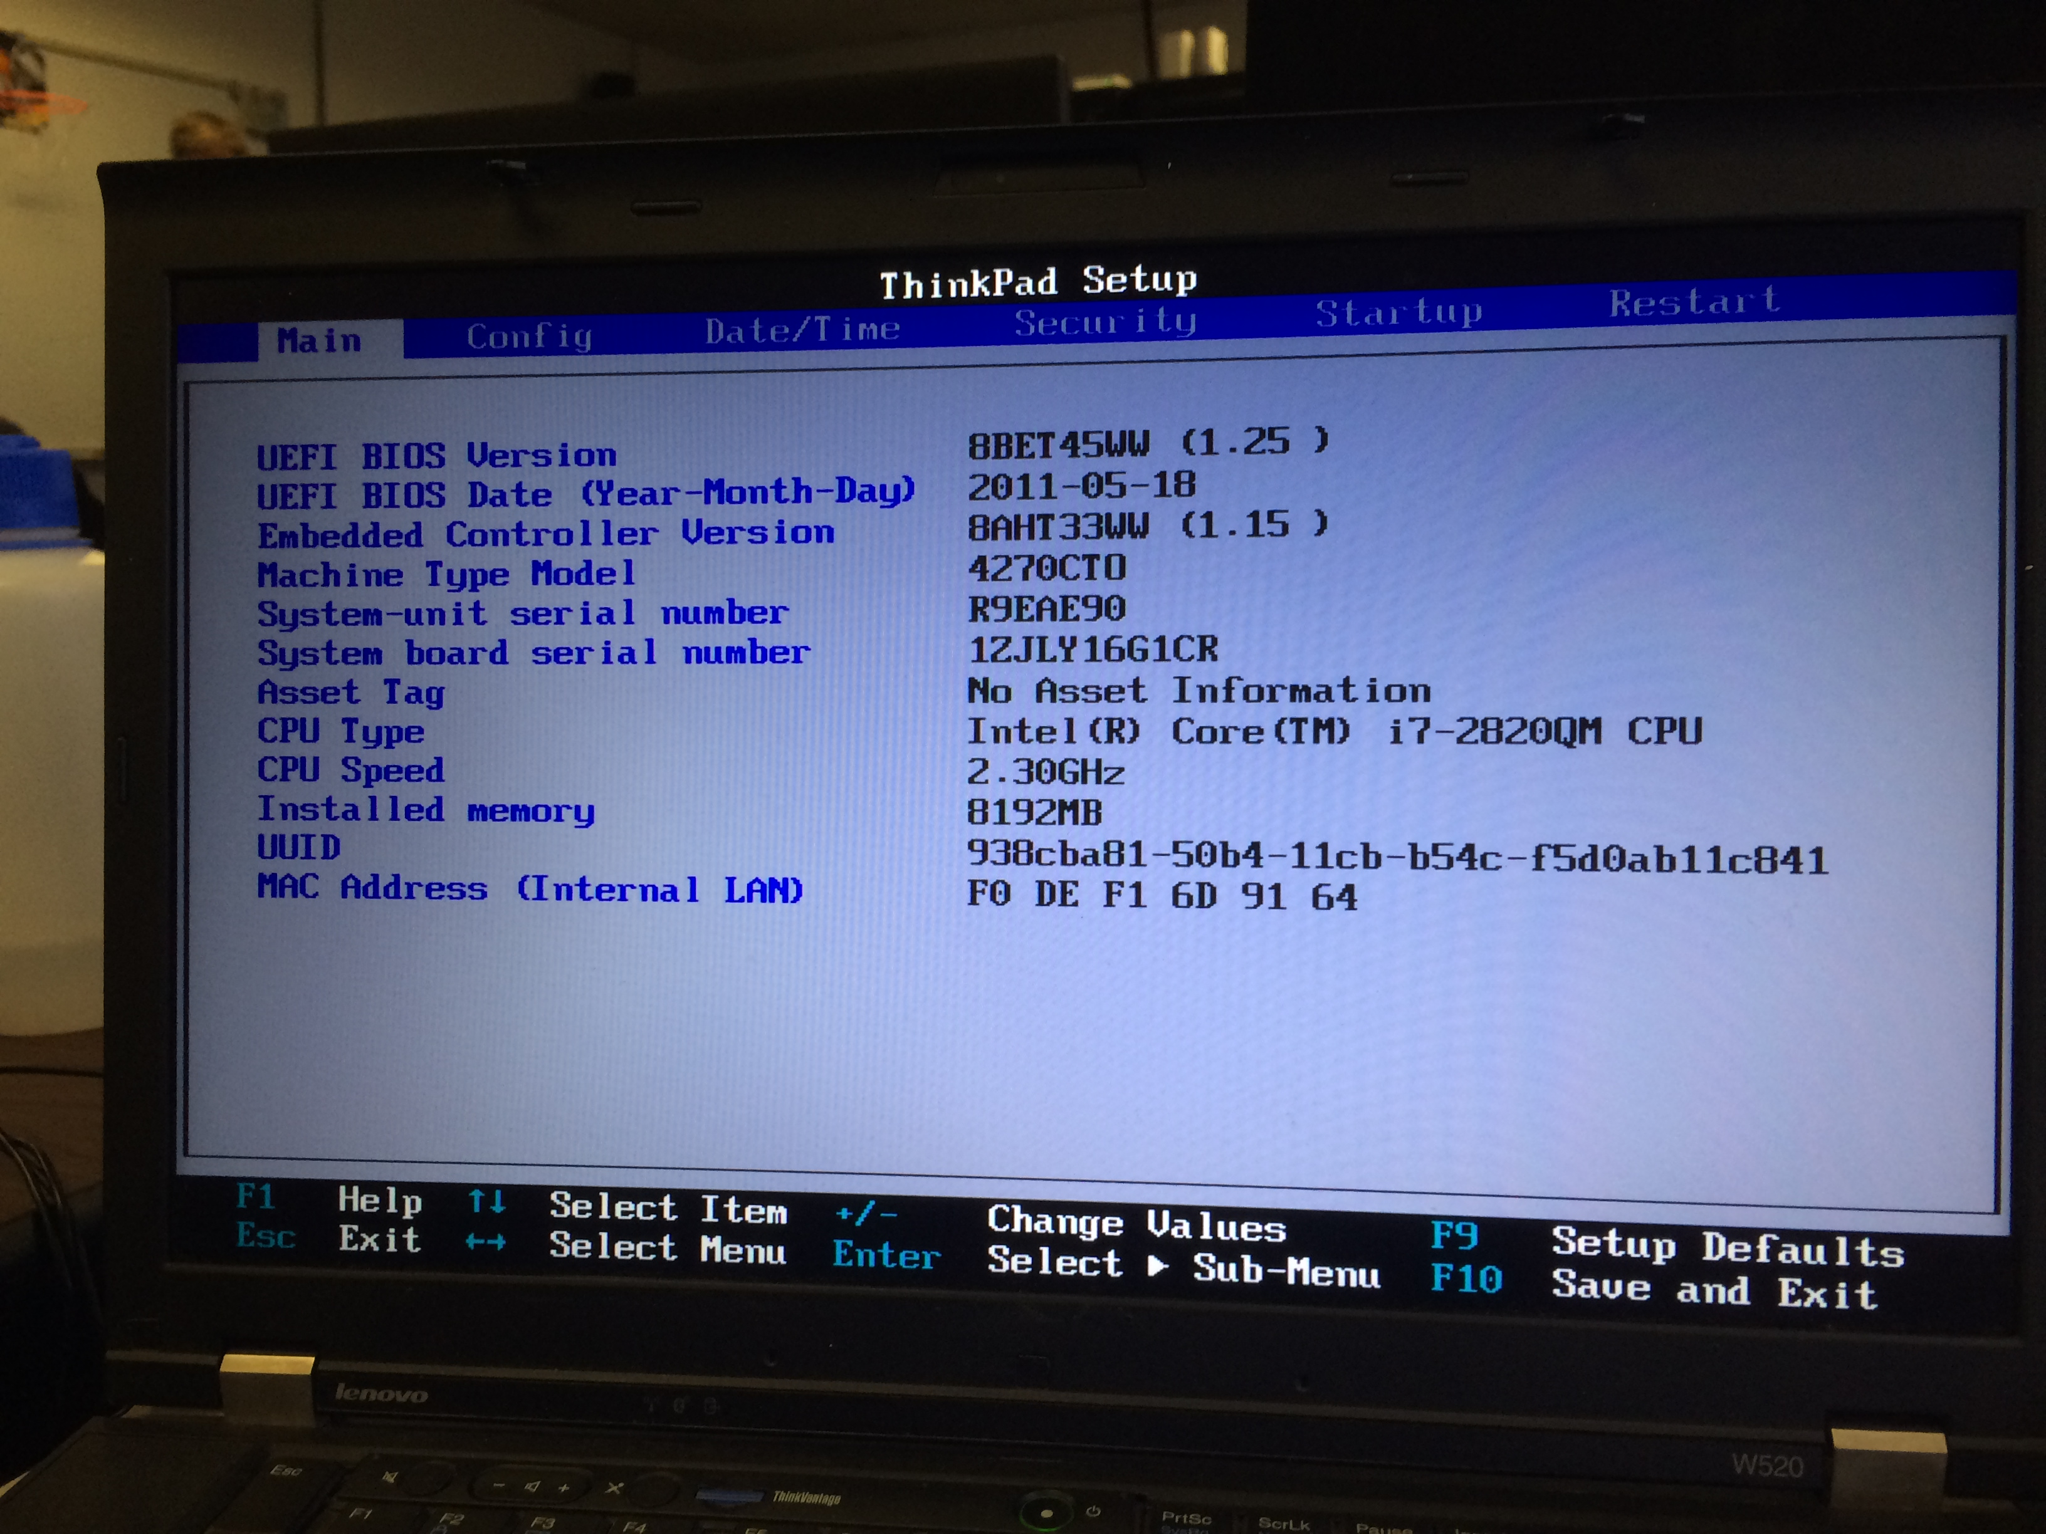

Kernel files:

